Project Design Phase
Problem – Solution Fit Template

Date | 08th October 2026
Team ID | 9100FusionForce
Project Name | Script Controlled ACL
Maximum Marks | 2 Marks

Problem – Solution Fit Template:
The Problem-Solution Fit for Script-Controlled ACL means identifying the difficulties organizations face when managing access controls manually in ServiceNow and providing a scripting-based solution that makes ACL creation, configuration, and management more efficient, consistent, and secure. It helps administrators reduce repetitive work, minimize configuration errors, and ensure that users have the appropriate level of access to data and applications.
Purpose:
❑ Solve complex access-control problems by automating ACL configuration according to specific user roles, conditions, and requirements.
❑ Improve efficiency and reduce manual effort by using scripts to create and manage ACLs instead of repeatedly configuring access rules manually.
❑ Increase security and consistency by ensuring that access permissions are applied according to predefined rules and organizational requirements.
❑ Reduce configuration errors by automating repetitive ACL tasks and maintaining standardized access-control logic.
❑ Improve access management by ensuring that authorized users can access the required resources while unauthorized users are restricted.
❑ Understand the existing access-control situation in order to identify security gaps and improve permission management for the target users.
Templates:
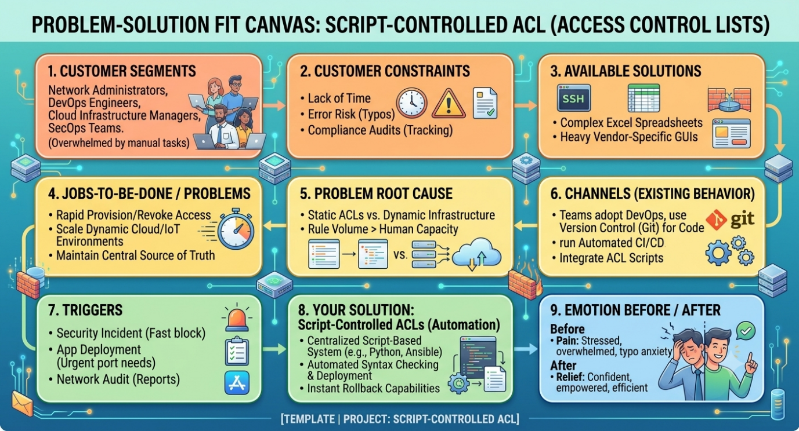

References:
- https://www.ideahackers.network/problem-solution-fit-canvas/
- https://medium.com/@epicantus/problem-solution-fit-canvas-aa3dd59cb4fe

